Wisconsin 101:
Our History in Objects
Lesson Plan

Analyzing Digital Primary Sources
Written by: Suzanna Schulert

What is the purpose of this lesson? To get students to find connected primary sources through Wisconsin 101 and Recollection Wisconsin digital collections

What will students produce? Description and URL of two primary sources and written work explaining the connection between them

Wisconsin Social Studies Learning Priorities:
- Inq2.a: Gather diverse sources (electronic, digital, print, and other mass media) applicable to the inquiry
- Inq2.b: Evaluate sources
- Inq3.b: Cite evidence from multiple sources to support a claim
- Inq3.c: Elaborate how evidence supports a claim
- Inq4.a: Communicate conclusions
- Hist3.a: Connections
- Hist4.a: Historical context
- Hist4.b: Intended audience
- Hist4.c: Purpose
- Hist4.d: Point of view (POV)

Analyzing primary sources together is a valuable historical skill for students to practice. At Wisconsin 101, we focus on objects as primary sources. In this activity, students will select a Wisconsin 101 object to work with, find a second related digital primary source to work with, and use secondary sources to write a 1-2 page analysis of these primary sources.

Selecting Primary Sources
Students can view a full list of Wisconsin 101 object histories and select one that interests them, or you can assign time periods, subjects, and/or locations as suit your learning goals. From there, students can search for an accompanying source on Recollection Wisconsin. This page on Recollection Wisconsin can help students locate historical newspaper articles.
Variation: You can also do this activity with physical objects such as ones from your local historical society, a field trip site, or objects from the “Your Story and Wisconsin’s Past” assignment.

Analyzing Primary Sources
Students will then familiarize themselves with their object history and analyze their Recollection Wisconsin source. The accompanying worksheet can support this analysis. Related Wisconsin 101 stories along with your course materials can provide secondary sources to help students contextualize their primary sources.

Reporting Conclusions
Based on their source analysis, students will write a 1-2 page explanation of what they see as the most interesting or important connection between these primary sources. In effect, this is a kind of simple thesis. Students will use their primary sources and information from secondary sources to support their claim that 1) this connection exists and 2) that it is important. The significance of the connection could be that it illustrates a pattern of change or continuity over time, gives insight into an important historical event, shows history’s current implications, etc. This analysis should include:
- A claim about the connection between the sources and its significance
- Descriptions of both primary sources
- Specific evidence supporting their claim
- If you’re teaching citation skills, students can use in-text citation and provide a bibliography

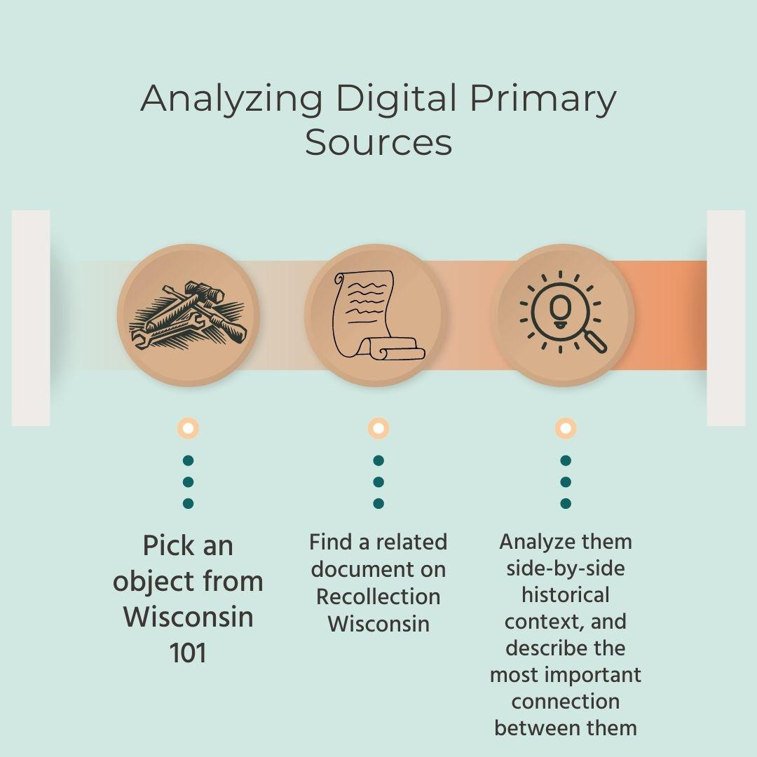

Object Primary Source

In a few sentences, describe the object you’re working with. What is it? What does it do? What is it made of?

When and where was this object made and used?

List any specific people, organizations, or communities connected to this object and circle the ones that interest you most:

List some key historical events and themes connected to your object (e.g. Progressivism, First Nations, dairy, lead mining, civil rights, etc) and circle the ones that interest you most:

Finding a Second Primary Source

Visit Recollection Wisconsin and search their collection for a document, photograph, or newspaper article related to your object. This page can help you locate newspaper articles. Look back at the people, themes, and events you noticed connected to your object, especially the ones you circled. These can be useful search terms for identifying related sources. You can also filter your search by location or time period to focus on when and where your object was used.

List 3 possible primary sources from Recollection Wisconsin to analyze alongside your object:

Take a closer look at all 3 of those sources. Which one do you think has the most significant connection to your object? Describe that source in a few sentences including:
- author or audience
- medium
- date
- purpose
- audience

Analyzing Primary Sources Together

Now take a look at the stories related to your object on Wisconsin 101 and think about your course resources. List 3 secondary sources that might help you add historical context to the connection you’re seeing:

In a few sentences, explain the connection you see between your two primary sources and why you think it’s significant (e.g. what does it say about a place or historical event, how does it inform current events, what does it show us about patterns of change or continuity over time)

Once you’re familiar with your primary and secondary source, list out 5 pieces of evidence that show the connection you’re seeing or the significance you identified. Be sure to include at least once citation for each piece of evidence.
- asdflkj;lakjdslfj kal
- asdf
- asdfsadf asdf
- asldkf;lkasjdflk;ajsd;fkljsldkjflskjdf
- asdfasdf

