Wisconsin 101:
Our History in Objects
Lesson Plan

Classroom Museum
Written by: Suzanna Schulert

What is the purpose of this lesson? Encourage students to collaborate and draw connections between primary sources to craft a historical narrative.

What will students produce? Object groupings with written metanarrative. Digital or physical

Wisconsin Social Studies Learning Priorities:
- Inq2.a: Gather diverse sources (electronic, digital, print, and other mass media) applicable to the inquiry
- Inq2.b: Evaluate sources
- Inq4.a: Communicate conclusions
- Geog4.a: Characteristics of place
- Hist1.a: Cause
- Hist1.b: Effect
- Hist2.a: Patterns stay the same over a period of time
- Hist2.b: Patterns change over a period of time
- Hist3.a: Connections
- Hist4.a: Historical context

Starting from “Your Story and Wisconsin’s Past”
If your class has done the “Your Story and Wisconsin’s Past” lesson, students can make exhibits from these objects. Have students review all the objects in the class through presentations or viewing objects and reading descriptions, and then have students brainstorm themes/locations/time periods (e.g. industry, tourism, the 1920s) they see represented in the objects.
Activity: To help create clusters of related objects, post signs around the room each listing one of the brainstormed themes/locations/time periods and have students stand by the sign they think best fits their object. Combine, remove, and subdivide groups until they are of desired size.
Once students are grouped, have them identify a main idea they want to convey with their exhibit.

Starting from Themes/Location/Time Period
You can also choose to start from a group of themes/locations/time periods and have students select objects suited to that theme.
- If you’re focused on Wisconsin history, you can use Wisconsin 101 subject headings or interactive map to group students and have them select an object history from our collection to work with.
- Select some key themes or time periods from your course (or have students brainstorm themes they’ve seen in the course) to group students. Have each student select an object related to that theme from their course resources, Wisconsin 101, the WHS digital collection, or the Smithsonian online collection.
Once students are grouped, have them identify a main idea they want to convey with their exhibit.

Creating Exhibits
Once students are grouped with their chosen objects, they’re ready to make exhibits. If you’re working with physical objects, students can create signage to accompany them. If you’re working with digital sources, students can create virtual exhibits like the ones we have on Wisconsin 101 on a variety of platforms such as:
- Google Docs or Slides
- WordPress
- Canva
- Padlet
Groups will arrange the objects and write accompanying metanarrative connecting the objects and providing historical context. Depending on the size of the group or the theme they’re working with, students may choose to subdivide they’re objects into smaller groups. The accompanying worksheet can help with that process. Here are some suggestions of ways to arrange objects in exhibits:
- Topic Clusters - for some exhibits, it might make the most sense to cluster a few objects together under their own topic. For instance, if a group is working on the theme of military history, they might have a cluster of WWI objects and a cluster of WWII objects. For this format, students should write a couple sentences explaining what unites this cluster of objects. Each object should also have a few sentences of description and connection to the main idea. Wisconsin 101 virtual exhibits often use topic cluster.
- Timeline - some exhibits lend themselves to creating a timeline with the objects. You can make a timeline placing the objects with a few sentences of description connected to the main idea interspersed with relevant historical context connected to the main idea. This timeline shows the history of World Expos in 40 objects.
- Series - placing objects in a series can help show change over time or cause and effect. This differs from a timeline in that some objects may be difficult to pin down to a date, but still show a process over time. For instance, an exhibit including a vinyl record, a cassette tape, a CD, and an mp3 player shows change in audio technology over time but each of these objects was used for long and overlapping periods of time making them difficult to make into a finite timeline. Each object should have a few sentences of description and connection to the main idea and a few sentences explaining the transition from one object to the next comes in between. This virtual exhibit from the National Women’s History Museum shows how objects in a series, but not necessarily in chronological order, can tell a story.
- Geographic - arranging objects on a map can help students show continuity or variation across geographic regions, or tell a statewide story. For this type of exhibit, students should write a paragraph explaining what these objects say about this geographic region, and each object should have a paragraph describing the object and connecting it to that main idea. In the simple example below, objects from Wisconsin 101 illustrate recreation and tourism in our state from summer and winter sports in the Northwoods to Door County’s bustling tourism industry to model boating in Madison’s urban parks. 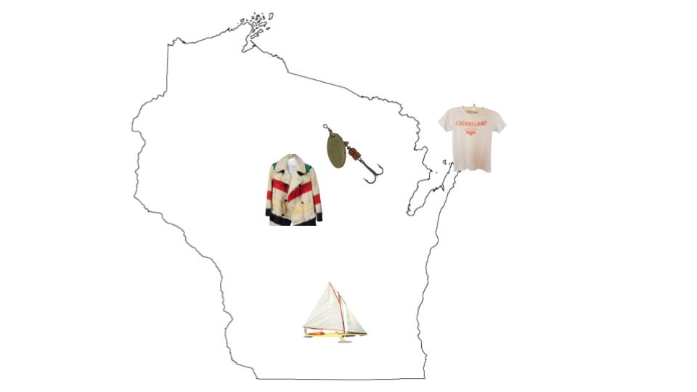
- Students can arrange their objects in any way they can dream up so long as it helps them talk about the main idea. Google Arts & Culture has many examples of virtual exhibits from institutions all around the world that can inspire more ideas of how to arrange objects to tell a story about history.

Exhibit Planning Worksheet

What is your group’s theme?

In a sentence or two, what is the main idea you want your exhibit to show viewers?

How does your object fit into the main idea?

What are some key points of historical context that will help viewers understand your object and the main idea?
- alsdjfl;skdf;jalksjdl;kajs;dlfa
- alkjasd;lfjsakl;djf;lsjdfl;jsl;kdjfl;kajsdf
- jksad;ljkf;alskdjf;ljsakdl;fkajls;kdjfl;akj

Now take a look at all of the objects in your group together.

Do you see change or continuity over time in the objects? How so?

if you put the objects in chronological order, do you see any patterns?

Do you see any thematic groups among the objects? Which ones?

Get together with the rest of your group and discuss the patterns and groups you saw. Together you can decide how best to arrange your objects for exhibit. Remember to connect everything back to the main idea.

Cluster

What is the main idea of the exhibit?

What is the title of this cluster of objects?

In a few sentences, explain how the cluster connects to the main idea of the exhibit

In a few sentences, describe your object and how it fits into the cluster and shows the main idea

Series

What is the main idea of the exhibit?

What process, change, or development does this series of objects show?

In a few sentences, describe your object and how it connects to the main idea:

What objects come before and after yours in the series?

In 1-2 sentences, how does your object connect to the one before it? The one after?

Timeline

What is the main idea of the exhibit?

What date range will your timeline cover?

In a few sentences, explain what this timeline will show about the main idea:

In a few sentences, describe your object and how it connects to the main idea including its date on the timeline:

What important dates fall around your object on the timeline? Why is each important to show the main idea?

