Wisconsin 101:
Our History in Objects
Lesson Plan

Viewing an Object from Multiple Perspectives
Written by: Suzanna Schulert

What is the purpose of this lesson? Have students, either collectively or individually, analyze how an object could have different meanings for people with different connections to the object or positions in the community.

What will students produce? Variety of possible work products

Wisconsin Social Studies Learning Priorities:
- BH3.a: Social Interactions
- BH4.a: Progression of technology
- Econ1.b: Incentives
- Econ2.a: Consumers, producers, and markets
- Hist1.a: Cause
- Hist1.b: Effect
- Hist4.a: Historical context
- Hist4.b: Intended audience
- Hist4.c: Purpose
- Hist4.d: Point of view (POV)

Just as we can read written sources from multiple perspectives, we can also view historical objects from a variety of angles. In this activity the class, or groups of students, will consider the individuals, communities, and institutions connected with a single object and describe the object from these perspectives. You can use any object for this activity, but here are a few from Wisconsin 101 with example perspectives students might work from:
- The Harley-Davidson V-Twin Engine
  - Engineers, Harley-Davidson factory worker, Milwaukee Police Dept, resident of urban Wisconsin, resident of rural Wisconsin, visitor to the Harley-Davidson museum today
- The Canfield Temperance Case
  - Cordelia Canfield, Yankee migrant to Baraboo, German migrant to Baraboo, Wisconsin State legislator, visitor to the Sauk County Historical Society today
- Sholes & Glidden Typewriter
  - Sholes, workers at the Remington Company, designers at the Remington Company, 1874 typewriter user, 21st century viewer
- X-Ray Shoe Fitting Machine
  - Manufacturer, seller/distributor, shoe store owner, shoe store clerk, show store customer, 21st century viewer

Brainstorming Perspectives
Having students brainstorm about perspectives they could view the object from can encourage them to think about the context in which the object was made and used. The attached worksheet can help guide that brainstorming process. For most objects, these perspectives are be a good place to start:
- Designer
- Producer
- Seller/Distributor
- User

Work Product
This activity lends itself to a myriad of work products depending on your classroom goals. Most simply, you can assign each student a perspective and they can write a paragraph describing the object from that perspective. This can also be an in-class activity in which you make small groups, each focused on one perspective, and have students discuss the perspective in their groups and briefly present their conclusions to the class. These paragraphs or presentations should include:
- Whose perspective they’re working from
- How did that person interact with the object
- When and where did they interact with the object
- What would they say the object’s purpose is
- What is the object’s connection to their life
- What would they say is the object’s most important feature
Students could also select multiple perspectives and produce creative narratives about the object. For example:
- Students can write a fictional historical newspaper article announcing the object’s debut that includes multiple perspectives on the object such as the maker, a competitor, a user, and some opposed to the object’s use.
- Students can write/illustrate a children’s story about the object showing how different people interacted with the object.
You can also have students work in groups with each student focusing on a different perspective. Groups can produce audio/visual presentations such as:
- Podcasts featuring interviews with people invested in the object.
- A newscast announcing the debut of the object or a controversy around it.

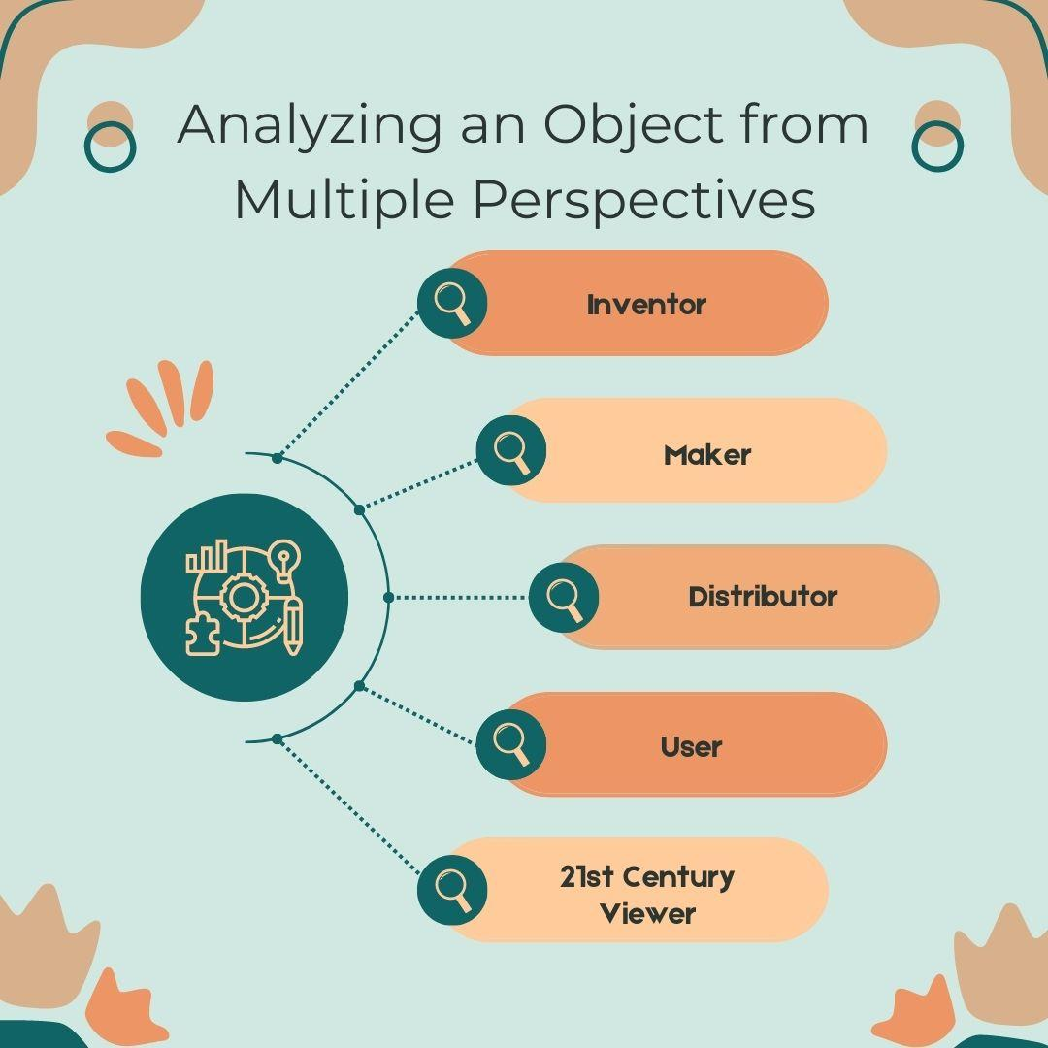
Brainstorming Worksheet

Who invented or designed this object?

Was this object mass produced?

Who made it?

Who was the object made for (any particular person, kind of user, or organization)?

Did the maker need to work with anyone else to create it (such as another manufacturer, industries that produced raw materials, artists, etc)? Who?

Did anyone not want the object to be made? Who?

Once the object was made, who wanted to have, use, or see it?

Did anyone help get the object from maker to user? Who?

Was the object subject to any oversight or regulation? By whom?

Do people still interact with this object today? Who?

Reading an Object from a Perspective

Whose perspective are you thinking from?

How did they interact with the object?

When and where did they interact with the object?

What would they say the object’s purpose is?

What is the object’s connection to their life?

What would they say is the object’s most important feature?

