Wisconsin 101:
Our History in Objects
Lesson Plan

Developing Skills in Object History:
Your Story and Wisconsin’s Past
Written by: Suzanna Schulert

What is the purpose of this lesson? To get students asking questions about history, using sources to answer them, and writing about what they found.

What will students produce? Written paragraph and source list

Wisconsin Social Studies Learning Priorities:
- Inq1.a: Develop questions based on a topic
- Inq1.b: Plan an inquiry
- Inq2.a: Gather diverse sources (electronic, digital, print, and other mass media) applicable to the inquiry
- Inq2.b: Evaluate sources
- Inq4.a: Communicate conclusions
- BH4.a: Progression of technology
- Hist2.b: Patterns change over a period of time
- Hist2.c: Contextualization
- Hist3.c: Current implications

At Wisconsin 101, we believe physical objects can help us tell stories about ourselves and how Wisconsin has changed over time. Once students have had some experience thinking about history and conveying their ideas in writing, this activity can get students writing about objects and be a building block for larger projects.

Choosing an object
Have students choose an object from home that’s important to them and connected to Wisconsin’s past. Be sure to encourage them to select something they reasonably think they can learn more about.
Meeting learning goals: You can direct object selection more to suit your learning goals. E.g., a piece of technology (BH4.a), an object related to self-image/identity (BH1.b), or objects connected to a migration story (Geog2.b). You can also provide objects for the class on a particular theme or have students do this activity with objects at a field trip site.
Inquiry
Students can begin by describing their objects.

Have students brainstorm a list of closed- and open-ended questions to guide inquiry into the objects. (Inq1.a)

Have students gather and review a variety of sources to help answer their questions. (Inq2.a)

Writing Your Story
Students will describe their object and tell its story in a paragraph or two. Length can vary depending on your learning goals and your students’ writing skills. The paragraph(s) should do the following:
- Describe the object (what it is, how it works, what it does)
- Say how old the object is
- Answer at least one of the following questions (Inq4.a):
  - Why is this object important to you?
  - How does this object show continuity or change in your community over time? (Hist2.a; Hist2.b)
  - What does this object say about trends in Wisconsin history? (Hist2.c, more advanced students can provide historical context from the time the object was made or used)
  - How does this object from the past connect to your life now? (Hist3.c)
  - How did this piece of technology affect daily life? (BH4.a)

Next Steps
You can have students submit their paragraphs to you, or you can add more elements such as:
- Students can create different types of presentations such as oral presentations or short videos to share their stories.
- Create a classroom museum with these objects. Students can work together to organize the objects and stories thematically or chronologically.
- Find a related primary source and analyze these sources alongside one another.
- Students can submit their objects to Wisconsin 101. (Inq5.a)

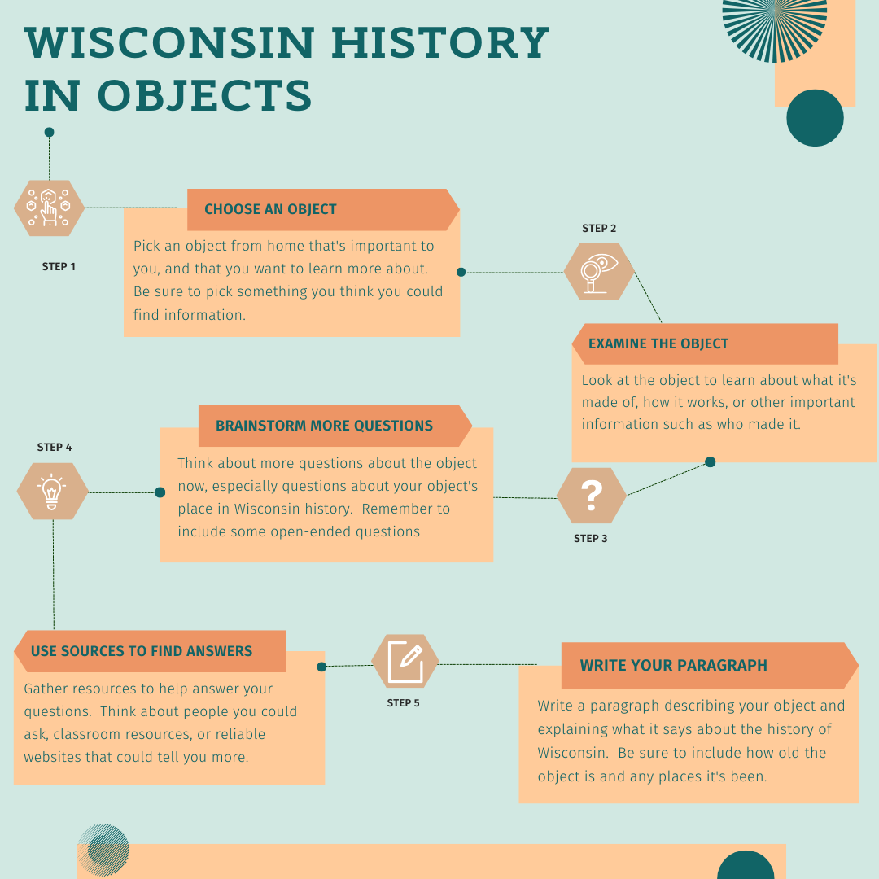

Object History Worksheet

Step 1:
Begin by writing a few sentences describing the object and what you already know about it. Some things to think about include:
- What the object is made of
- What the object is, what is does
- The age of the object
- Where it came from

Step 2:
Write a list of questions to help you learn more about this object and how it connects to Wisconsin history.
Closed-Ended Questions | Open-Ended Questions

Step 3:
Gather at least three different sources to help you answer your questions. List them here:

Step 4:
After you’ve analyzed your sources and found some answers to your questions, think about what you learned about the object and its place in history. Ask yourself these questions to help think about the main point you want to make about your object.
- What stands out most to you about the object? Why does it stand out to you? ksdjfa;lfdkjfalkjdslkjfalksdjflksjdflksjdflksjdflkasdfjklas;ldfkas;ldkfjlksdjfkdsakdfj;lsdkfjlkasjdflaksdjflksjdflaskdfj;lskdjflsakdjflkasjdflaksjdflaksjdf
- What does the object tell you about Wisconsin of the past or present? ksdjfa;lfdkjfalkjdslkjfalksdjflksjdflksjdflksjdflkasdfjklas;ldfkas;ldkfjlksdjfkdsakdfj;lsdkfjlkasjdflaksdjflksjdflaskdfj;lskdjflsakdjflkasjdflaksjdflaksjdf
- Why do you think this object is important to Wisconsin history? ksdjfa;lfdkjfalkjdslkjfalksdjflksjdflksjdflksjdflkasdfjklas;ldfkas;ldkfjlksdjfkdsakdfj;lsdkfjlkasjdflaksdjflksjdflaskdfj;lskdjflsakdjflkasjdflaksjdflaksjdf

Based on your answers to those questions, decide what you want to focus on for your story. In other words, what do you want your reader to learn by reading it? This is your main idea. In a sentence or two, what’s the main idea of your story?

Step 5:
Complete the sentences below with important bits of information from your sources that help get to your main idea:
Red – describe the source. Are they a historian? The person who gave you the object? A museum’s website?
Blue – name the source such as the author or organization’s name
Black – the important piece of information for your story in your own words

∙According to , .
EX: According to National Museum for American History curator Deborah Warner, the first toothbrushes were probably made in China sometime around 618-907 C.E.
∙ believes that .
Ex: Historian Robert Fries believes that waterways connecting abundant forests with regions lacking building materials spurred the growth of the lumber industry in 19th century Wisconsin.
∙ such as report that .
Ex: Local residents such as Sarah Smith report that the Ella’s Deli carousel was a part of many childhood memories.

